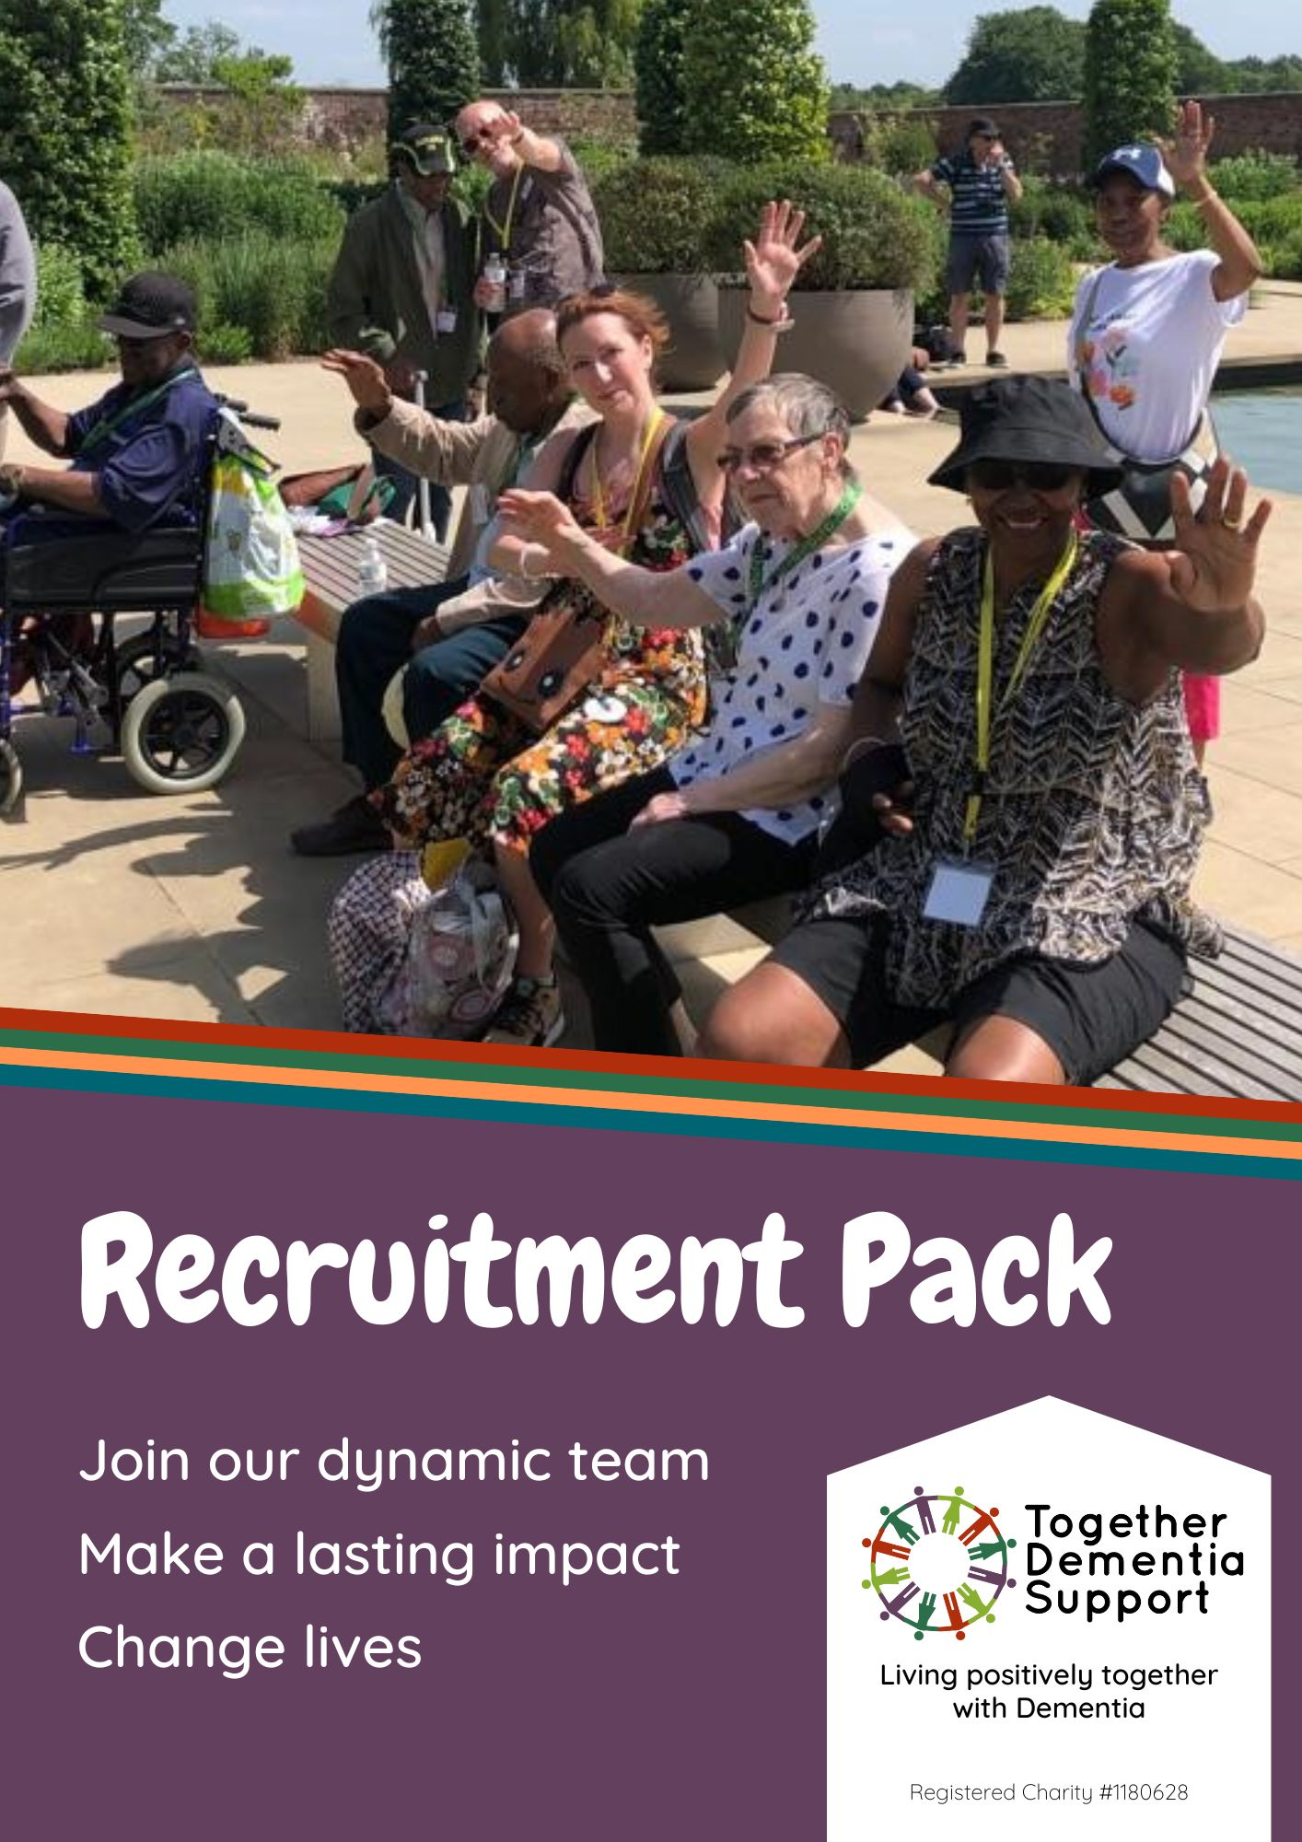

## **Background information**

Together Dementia Support (TDS) is now 10 years old, and thanks to the National Lottery Reaching Communities Fund, and multiple trusts and foundations, we have developed from a small group of volunteers to a professional charity with 13 staff 96 volunteers and a turnover of £494,000.

In 2024 we worked with almost 1,000 people, those living with dementia (PLWD) and unpaid family carers. We have pioneered specialist community dementia support services and developed an enormous amount of experience of how to make meaningful moments, and sustainable caring accessible to our diverse Manchester communities. Take a look at our website to see how busy we are.

Although there are many advances in medical research there is no cure for dementia and little in the way of interventions from the NHS. The many variants of the disease – from Alzheimer’s to Vascular, Lewy Body, Frontotemporal, and mixed dementia - continue to impact on thousands of families per annum. In the next few years there will be 3,000 people with a diagnosis in Manchester alone. Unpaid carers continue to struggle with little support available.

TDS has reached a critical time in its development. We have just secured our third Reaching Communities award from the National Lottery, which enables the organisation to feel more confident about our future prospects. Diversifying our income streams, securing corporate partnerships, and growing legacy giving are priorities for the Income Generation Manager.

Despite the challenging funding climate, TDS wishes to grow so that it can support people impacted by dementia for as long as they need us. We hope you will be inspired to join us, and play a key role in our dedicated team, and in future.

Kind Regards,

Sally Ferris, CEO

|  |  |
| --- | --- |
| Job Title: | Sessional Support Workers |
| Reporting to: | Together Out & About Co-ordinator |
|  |  |
| Contract: | Casual |
| Probation Period: | 3 months |
| Hours: | Minimum 4 hours a week. 2.5 hours Together out and about session with 1.5 planning and travel time. |
| Location: | Manchester – in the community. Some time spent in the Kath Locke office and at home. |
| Salary: | £13/hr which equates to £52 per session. |

**Role Description**

**Together Out and About** is a new 1:1 service. We recognise that people living with dementia, in particular younger people, or those newly diagnosed, have difficulties going out on their own, and as a result become isolated from their communities, many losing friendships as a result. The aim of this service is to get to the know the person, learning what interests them, creating a plan of places to go and things to do in their locality, during their weekly or fortnightly 2.5-hour session. This companionship level of support (not personal care) may enable them to regain independence, reduce social isolation, have new things to talk about, meeting new people, become happier, boosting cognitive function, whilst also becoming more physically active.

**Main purpose of job:**

1. To work with Together Out & About clients, including making a **person-centred** plan with the person with realistic, time-managed engaging and stimulating activities, to enable the person to engage in their community during the visits, e.g. museum trip, shopping, exercise class
2. Researching, planning and risk assessing all outdoor activities and venues before carrying it out.
3. To write up notes about the visit and collect basic outcome data.
4. To discuss clients with the Together Out and Out project co-ordinator, passing on any concerns about either the member or the family carer.
5. Liaise with family carer about planned activity and to give feedback.

**Additional responsibilities:**

1. To adhere to the policies of TDS.
2. To comply with Health & Safety policies and procedures, and data protection regulations, ensuring that all client information remains confidential.
3. To maintain accurate and up to date client records and activity logs and other paperwork as directed by the Project Co-ordinator
4. To work in a manner that facilitates inclusion and empowerment, particularly of people with dementia and their carers.

|  |
| --- |
| **Person Specification** |
| A good understanding of dementia and how it affects people with a diagnosis and their relatives |
| An understanding of the black British, Black African, African Caribbean or South Asian communities, their religions and cultures, and how these might impact on their experience of ageing, dementia and care |
| Good communication, organisational and time management skills |
| Ability to think on your feet, responding to changed circumstances or wellbeing of a member |
| Ability to use Microsoft Office programmes for creating documents, sending e-mails, inputting data to spreadsheets etc. |
| Ability to use online video conferencing programs, such as Zoom |
| Ability to generate ideas, research and plan activities and equipment independently |
| Experience of working/volunteering face to face with older people |
| A basic understanding of adult safeguarding and risk assessment |
| **Personal attributes/qualities** |
| Commitment to improving the quality of life of people with dementia and their carers, doing this in a collaborative, empowering way |
| Good team worker; willing to learn from, support and reflect with other TDS staff |
| Able to listen well and with empathy, displaying unconditional positive regard to those we are trying to help but being alert to carer stress, family difficulties, neglect and abuse |
| Able to put people at ease and converse easily with them. |

**Expenses**

If you are required by your role to travel during the course of your duties, we will reimburse you for mileage in line with HMRC policies. Currently, this is 45p per mile. If you use a taxi, we will reimburse 45p per mile and you must cover the rest (as a driver must cover the rest of their petrol and maintenance costs). We will pay the full expense of a bus ticket.

**Equal Opportunities**

We strive to ensure that our roles are accessible to everyone possible and are happy to make reasonable accommodations for any disabilities, health conditions or neurodiversity.

We want everyone, no matter their background or abilities, to feel comfortable, happy and included in our services. Our current staff come from a range of backgrounds and experiences, and we work hard to ensure that our staff and volunteer cohorts reflect the rich, diverse and vibrant communities of Manchester and Trafford we work with.

**DBS Checks**

Most of our roles require a DBS check to be completed before you can begin working with our members and carers. If you are required to undergo a DBS check, we will pay for and facilitate this for you.

**If you are interested in working with Together Dementia Support and believe you have the relevant experience, skills, abilities and qualities for this role, please send us your CV and cover letter of 1-2 sides, explaining how you meet our criteria.**

**Please email your CV and cover letter to** [**claire@togetherdementiasupport.org**](mailto:claire@togetherdementiasupport.org) **or call 0161 226 7186 if you require any further information about the role. (**Applications **won’t** be considered unless a cover letter is supplied)

Interviews

Interviews will be held the w/b 21/04/2025. Interviews will be held at:

**Kath Locke Centre**

**123 Moss Lane East**

**Manchester**

**M15 5DD**

## Thank you for your interest in joining out team here. We hope to hear from you soon.