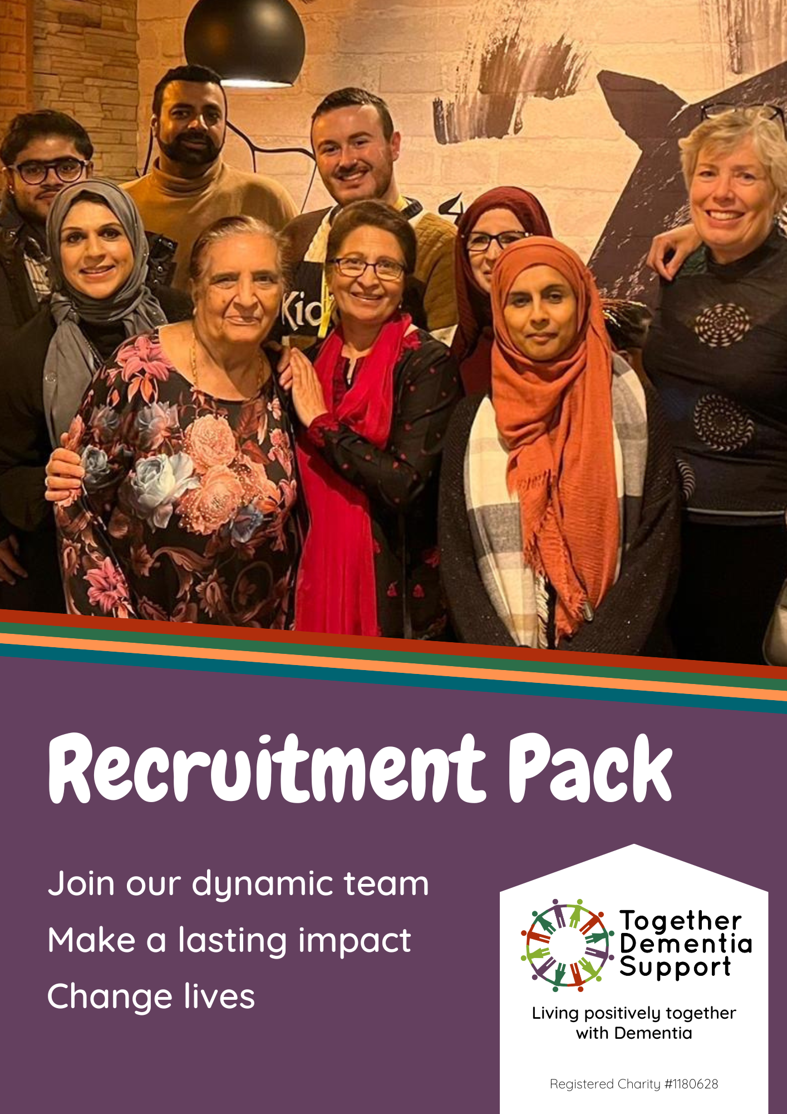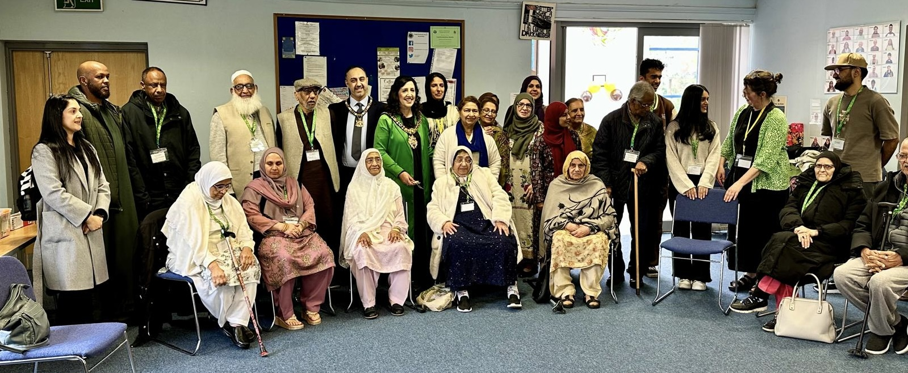

Welcome

## We are Together Dementia Support

Together Dementia Support was founded in 2014 by our CEO, Sally Ferris. Through her work experience in the dementia field, she saw the vacuum in support available to people after a diagnosis of dementia. She was shocked that people with the condition were left to decline, unsupported, at home and that no hope was given to either them or their families. There was no-one there to give information and emotional support, and there was certainly nowhere to go to see friends and enjoy activities and conversation.

Sally Ferris, CEO

BSc, MA, MSc Dementia Care

Sally decided to study for a master’s degree in Dementia Care at the University of Manchester, learning about evidence-based practice and how to lead change. She then felt that she had to put her learning into practice and create the sort of dementia community that would enable positive person-centred care and support for both the people living with dementia and their families. This is how Together Dementia support was born in 2014.

What started as a small Community Interest Company is now a thriving charity, with 11 FTE staff, 11 regular groups across Manchester and Trafford, and over 600 people regularly supported by the service. For people living with Dementia, we offer a range of activities such as social groups, walking groups, arts & crafts, music and games groups, as well as one-to-one at home social activity support. For carers, we provide online and in person group support, one-to-one advice and guidance, training opportunities, social outings, regular short-term respite and a friendly ear to listen.

What we do is unique, and the University of Salford conducted a study from 2019 – 2022 to assess the impact of our approach. They found, overwhelmingly, that people’s wellbeing significantly improved from our research and experience-based skill maintenance activities, positive social interaction, and positive and inclusive attitude to dementia. Our services could mean a person living with dementia is able to maintain functional skills for longer than they would have without our support.

Currently, it is estimated that over 5,000 people are living with dementia in Manchester alone but many of them are not getting regular support.

Join our team, help us reach more of the 5,000 people, and be the positive difference made in someone’s life.

There is no small role in our organisation, and everyone – from our minibus drivers and business support staff to our Dementia Support Co-ordinators– makes a difference with everything they do.

We hope you will be inspired by us, and see yourself as part of our friendly, thriving and dedicated team changing lives in Manchester and Trafford.

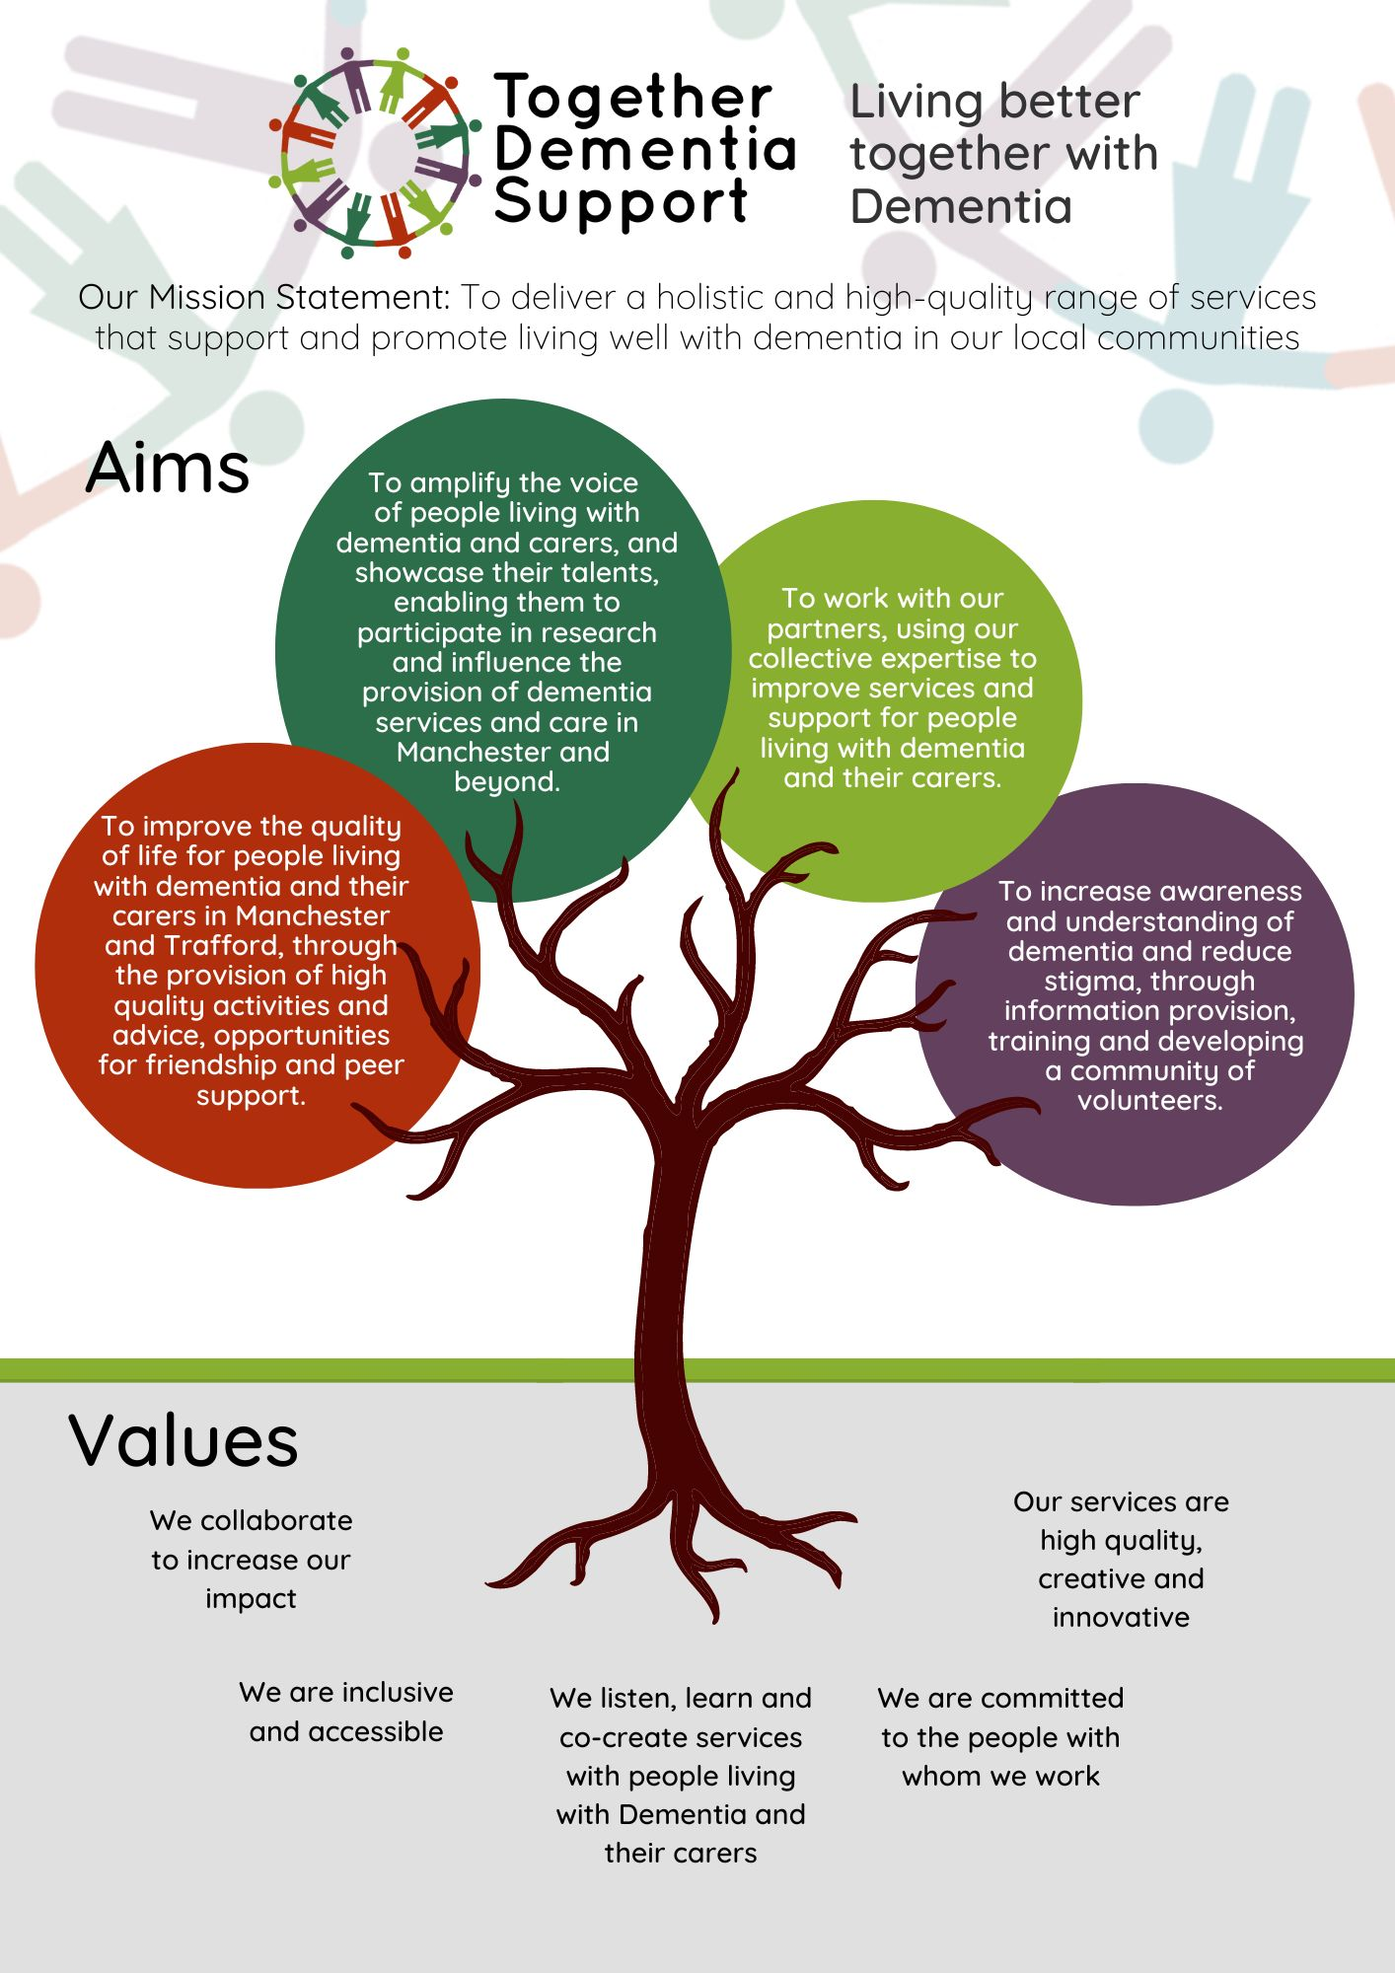

## Meet the Senior Leadership Team

|  |  |
| --- | --- |
|  | SALLY FERRIS BSc, MA, MSc Dementia Care **Founder & CEO**  Sally has worked with older people in the NHS, Social Services and voluntary sector for over 30 years. She chose to specialise in dementia support and has an MSc in Dementia Care. Sally loves the opportunities TDS has to have to offer innovative services that respond to local people’s needs – to make a real difference on the ground.  “**I look for people who have** **high standards and who are keen to learn and develop. We have an ethos of person-centred care, innovation, and commitment to our service users; our employees reflect this with everything they do.”** |

|  |  |
| --- | --- |
|  | MIKE GOVIER **Operations Manager**  Mike has recently joined the team as Operations & Data Manager. He has a background as an Electronics Engineer in the Flight Test Departments at British Aerospace. Mike worked in project management roles at various BAe Systems civil aircraft and military aircraft sites. Mike has then worked as a School Business Manager before becoming CFO for a Multi Academy Trust operating eight school sites alongside a teacher training SCITT.  **“TDS is a fabulous place to work where you can really make a difference and contribute skills in a way that you will find hugely rewarding. You will find a team of people with a great work ethic who strive hard to achieve the highest standards and outcomes for our members and carers”** |

|  |  |
| --- | --- |
|  | CLAIRE MARRETT **Service Delivery Manager**  Claire joined TDS in 2019, having worked in Salford for the previous ten years – supporting carers and people living Dementia for Age UK Salford. She also did engagement work with the Institute for Dementia at Salford University. She has a PGCert in Dementia and the Enabling Environment.  **“Excellent teamwork is one of the reasons TDS does what it does so well. I look for candidates who are dedicated to doing the best job they can for our clients, who support their colleagues and who are competent, kind, and strong communicators.”** |

## Benefits when working with TDS

Here at Together Dementia Support we are able to provide a competitive salary, plus extra benefits.

* Annual leave allowance increases in line with years of service.
* An attractive office space, with on-site cafe
* A staff discount scheme, covering popular brands such as Pandora, Look Fantastic, JD Williams, Argos, Boots and more. You can also save on your holidays with Ho Seasons, Cottages UK, TUI and others.
* Generous sick leave arrangements, increasing incrementally with years of service and supported by our Employee Assistance Programme. The programme also includes access to free counselling other well-being assistance tools.
* Ongoing professional development opportunities
* Regular wellbeing and team outings and activities
* Flexible working arrangements, depending on job role
* Free onsite parking at our main office

“Working with Together Dementia Support is so fulfilling. You get so much out of it, meet some amazing people, and you see week in week out the difference you are making to people's lives.”

~ Beth Langworthy, Carer Support Manager

## Some things you might need to know…

There are some basic things you may find useful to be aware of when applying to work with us.

**Annual Leave and Bank Holidays**

Full time employees are entitled to 25 days per year, or 175 hours. Part time employees have their leave allowance calculated pro rata based on this.

We do not work Bank Holidays, and Bank Holidays are not deducted from your Annual Leave Allowance. This means you get, on average, a further 8 days off.

If you are part time, the 8 days of Bank Holiday leave will be calculated pro rata for you so that you also benefit from the extra time off.

**Hybrid Working**

Where home working is possible, we can offer this as a working arrangement. This is not possible for every role, but the job description will make this clear.

**Expenses**

If you are required by your role to travel during the course of your duties, we will reimburse you for mileage in line with HMRC policies. Currently, this is 45p per mile.

Commuting is the responsibility and expense of each individual employee, and we cannot pay expenses for commuting costs.

**Equal Opportunities**

We strive to ensure that our roles are accessible to everyone possible and are happy to make reasonable accommodations for any disabilities, health conditions or neurodiversity.

We want everyone, no matter their background or abilities, to feel comfortable, happy and included in our services. Our current staff come from a range of backgrounds and experiences, and we work hard to ensure that our staff and volunteer cohorts reflect the rich, diverse and vibrant communities of Manchester and Trafford we work with.

**DBS Checks**

Most of our roles require a DBS check to be completed before you can begin working with our members and carers. If you are required to undergo a DBS check, we will pay for and facilitate this for you.

Carer Support Co-ordinator

We are seeking a full or part-time Carer Support Co-ordinator to join our growing team, and to work with our carers, becoming an expert in the needs of people with dementia and the services that they and their carers can access. The Carer Support Co-ordinator will manage a large, diverse caseload of family carers, building strong relationships, assessing their needs and interests, giving expert information and advice, finding services for them and then being their point of contact throughout their journey with dementia.

The Carer Support Co-ordinator will also be responsible for co- running our Friendship & Activity group, called Pyaari Yaadein, for our South Asian members who live with dementia each week. To do this they will need to relate well to people with dementia and have creativity and strong communication skills to plan and lead activities.

The CSC will also get involved in delivering carers’ dementia training and the many other carers’ treats and projects that TDS runs.

The post holder will work with other health and social care professionals to promote our work and will signpost or refer our members to other services and to access equipment, adaptations and welfare benefits.

We know that some people who may have the skills and passion for this role won’t have all the required knowledge and experience. Any applicants must have a commitment and interest to learn and develop the required expertise.

Hours

28-35 hours per week

Salary

£27,250 full-time (with 3% pay increase from 1 July)

|  |  |
| --- | --- |
| Job Title: | Carer Support Co-ordinator |
| Reporting to: | Carer Support Manager |
| Responsible for: | Planning, delivery and evaluation of services to people living with dementia and their carers |
| Contract: | 2 years but likely to become permanent |
| Probation Period: | 6 months |
| Hours: | 28 or 35 hrs pw |
| Location: | The Kath Locke Centre, 123 Moss Lane East, Moss Side, M15 5DD (but travelling across the city) |

## Responsibilities and duties

* To visit new referrals, assessing the support needs of both the carer and the person living with dementia (PLWD), and judging their suitability for our services for PLWD, whilst giving advice/information and emotional support to them both as they adjust to the diagnosis or changes caused by dementia;
* To write up all assessments and input data on our database;
* To report back to referrers and to make referrals to other services;
* To keep in regular contact with the families, giving advice and support as needed;
* To support and guide family carers through difficulties and transitions they may experience, encouraging them to join our carer activities;
* To support with or run Dementia Cafes, carer massage sessions, Carer Training courses, and carers’ socials;
* To give carers a voice within TDS and beyond by making sure that opportunities to participate in carers’ consultation events and co-production are known to them, supporting people who want to get involved and feeding their views and questions up to those who can effect change in carer, health and social care services. Also to support our volunteer Carer Champions;
* Keep updated and informed on local and national issues affecting carers and cascade information within the TDS team, keeping the Staff Reference Guide up to date;
* Work with TDS Carer Champions to provide support and encourage ex-carers to volunteer with us.
* To co-plan and run, with our current Pyaari Yaadein worker, the weekly Friendship & Activity Groups and/or cover for other colleagues if needed;
* To manage the health and safety of the Pyaari Yaadein F&A group, taking into account the venue, staff/member ratio, the activities, transport, and the individual support needs of members;
* To promote TDS services through advertising, social media, visits to other organisations, and by giving talks;

Additional responsibilities**:**

1. To adhere to the policies of TDS
2. To comply with data protection regulations, ensuring that all client information remains confidential.
3. To be responsible for personal learning and development and to share responsibility for the supervision, learning and development of the volunteers.
4. To implement the Health & Safety policies and procedures, ensuring that all practices and procedures are undertaken in accordance with a healthy and safe working environment and that all volunteers are aware of their responsibilities in respect of their role.
5. To maintain accurate and up to date records of attendance, petty cash and individual members’ online records;
6. To undertake any other tasks, duties or projects which may arise from time to time which are commensurate with the general level of this post and as directed by the designated line manager.
7. To carry out own administration and organisation of workload to ensure that it is accurate and meets quality targets, reasonable deadlines and grant monitoring requirements
8. To work in a manner that facilitates inclusion and empowerment, particularly of people with dementia and their carers.

**Please see the Person Specification on the next page for a full breakdown of qualifications, skills and experience necessary to be successful in this role.**

|  |  |  |
| --- | --- | --- |
| **Criteria** | **Essential (E)/ Desirable (D)** | **How Assessed**  Application From – AF  Interview – I  Task - T |
| **Qualifications** | | |
| Educated to A Level or above, or relevant experience | E | AF |
| Educated to degree level, or relevant experience | D | AF |
| A full UK driver’s licence and access to a vehicle | D | AF/I |
|  |  |  |
| **Experience & Knowledge** |  |  |
| Experience of working/volunteering with people living with dementia | E | AF |
| Lived experience of South Asian family life | E | AF |
| Experience of working with / supporting carers | E | AF |
| Experience of working face to face with older adults | E | AF |
| Comprehensive knowledge of Dementia and the needs of people with a diagnosis and carers | D | AF/I |
| Understanding of person-centred / client centred ways of working | E | AF/I |
| Knowledge about the welfare benefits, mental capacity, POA and Social Services entitlements | D | AF/I |
| Experience of working within, assessing and developing risk assessment procedures | D | AF/I |
| Knowledge and understanding of diversity and equality issues | D | AF |
| Understanding of health & safety issues as they affect clients, volunteers and staff | D | AF/I |
| Experience of running group activities (to educate, train or entertain) | D | AF/I |
| Able to understand and speak a South Asian community language confidently | E | AF/I |
| **Skills** | | |
| Excellent verbal and written communication skills | E | AF/I |
| Organisation skills to manage and prioritise own workload | E | AF/I/T |
| Ability to engage with service users and professionals at all levels | E | AF/IT |
| Strong IT skills, particularly in the use of Microsoft Office | E | AF/I/T |
| Ability to self-support administratively and manage own time | E | AF/I/T |
| Ability to create and lead culturally appropriate imaginative, participatory activity sessions, using music/drama/movement/art | D | AF/I |
| Able to motivate, encourage and support staff & service users | E | AF |
| Able to present / speak to small audiences | D | AF/I |
|  | | |
| **Qualities** | | |
| Able to work independently on own initiative and as part of a team | E | AF |
| Able to work flexibly and respond to the needs of the organisation | E | AF |
| Commitment to professional and personal development | E | AF |
| Commitment to the empowerment and support of people with Dementia and their carers | E | AF |

If you are interested in working for Together Dementia Support and know that you have the personality, experience and skills, please send us your CV with a Cover Letter (min.1 page long) explaining how you meet the criteria of the Person Spec.

Please email your CV and cover letter to [admin@togetherdementiasupport.org](mailto:admin@togetherdementiasupport.org) or call 0161 226 7186 if you would like any further information about the role.

## How to Apply

It is possible to apply for this role through the following channels:

Email: [admin@togetherdementiasupport.org](mailto:admin@togetherdementiasupport.org)

**You should return your cover letter and CV or summary document as soon as possible as we will interview when we have enough strong applications**

## Interviews

Interviews will take place before the end of May at our offices in Manchester.

Kath Locke Centre

123 Moss Lane East

Manchester

M15 5DD

Depending on candidates, there may be a 2-stage interview process where you will be invited to deliver an activity in a group should we be unable to appoint from the first stage interview.

## Thank you

Thank you for your interest in joining our team here at Together Dementia Support. We hope to hear from you soon!